- Interest Groups
- Special Interest Groups & their Purpose
- Interest Groups: are a linkage institution that connects people to the political process (also called FACTIONS)

- Interest Groups: aim to influence all three branches of gov’t in
order to impact the policy-making process

- Pluralism occurs when interest groups are vying for power & influence in gov’t

- Interest Groups can create iron triangles and/or
issue networks

- Iron Triangles
- Iron Triangles: The relationship between Congressional Committees, Government agencies (Bureaucracy) & Interest Groups (long lasting relationship):

i. Interest Groups – provide electoral support
ii. Committees- make favorable legislation
iii. Bureaucratic Agencies - receive funding from Congress & implement policy as Congress intends

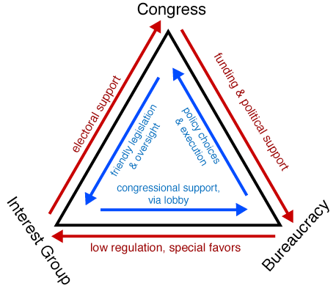

Issue Networks
- Issue Networks: Larger, Looser (more informal),
More Temporary Coalition (compared to iron triangles)

- Issue Networks are an alliance of various interest groups and individuals who unite in order to promote a single issue in government policy.

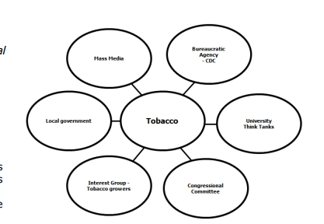
Issue networks coordinate efforts until issue is resolved despite possible conflicts in other policy areas

- Types of Interest Groups
- Single Issue Groups
- Professional Groups
- Social+Ideological Groups

D. Interest Group Influence is Impacted by…
- Inequality of Political & Economic Resources
- Unequal Access to Decision Makers
- Free Rider Problem

- /F Benefits & Costs of Interest Groups
Benefits | Costs
Interest groups create competition for influence that helps ensure a more equal distribution of power (i.e. all power does not belong to elites) | Interest groups tactics can be aggressive & overwhelming & by definition, interest groups promote their groups’ interest over the interest of others
Interest groups engage in lobbying to apply pressure to gov’t officials to support or halt policies | Lack of resources for smaller, less well financed groups results in some interest groups being more powerful than others
Interest groups can represent very broad issues, such as economic reform, or very specific issues, such as eliminating drunk driving  Our representative republic & system of federalism prevent the dominance of factions (Federalist # 10) | Hyper pluralism → when multiple competing interests develop; can result in gridlock  Free-rider problem → when individuals benefit from interest group influence w/o directly supporting group

